Customer and Market Behavior Analysis
A Power BI Dashboard Analysis

Prepared by:
Anetoh Olivia Chinecherem
Institution:
Digitaley Drive
Program:
Data Analytics Training Program
Tool Used:
Microsoft Power BI
Date of Submission:
3rd May 2026

1. Introduction
This report presents an analysis of customer behavior, campaign engagement, product performance, and channel effectiveness using Microsoft Power BI. The objective of this project is to evaluate customer characteristics, identify the most successful marketing campaigns, determine high-performing products, assess underperforming channels, and examine the factors influencing web purchases.
The dashboard was structured into five key sections: Customer Profiling, Campaign Response and Engagement Analysis, Commercial Performance Overview (Products and Channels), Web Purchase Behavior, and an Executive Overview. Each section was designed to answer specific business questions and provide actionable insights to support strategic decision-making.

2. Methodology
This section outlines the approach used to build the Power BI dashboard, including data cleaning, data modeling, measure creation, and dashboard design structure.
2.1 Data Cleaning (Power Query)
The dataset was imported into Power Query for data preparation and transformation. Several cleaning and restructuring operations were performed to ensure the dataset was suitable for analysis.
Missing values and outliers were identified and handled appropriately. In addition, data restructuring was carried out to improve analysis efficiency.
Key transformations included:
Removal of outliers in the Income and Age columns
Handling of missing values in the Income column using median imputation
Standardization of data types across all fields
In addition, data restructuring was performed through pivoting and unpivoting techniques, where necessary, to ensure proper analysis of categorical fields such as:
- Campaign responses
- Product categories
- Channel types (Web, Catalog, Store, Deals)
- Purchase-related variables
This ensured that the dataset was structured in a format suitable for aggregation, visualization, and cross-analysis in Power BI.
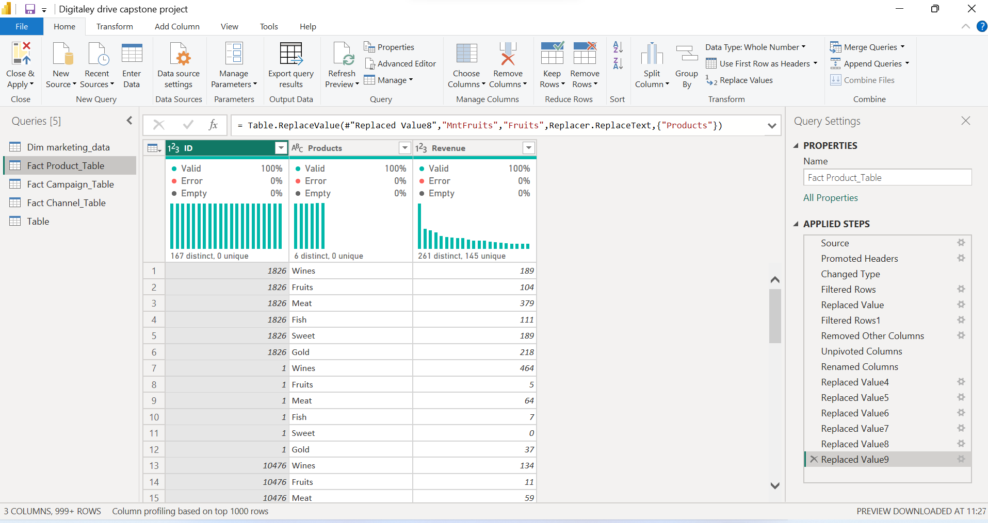
Figure 2.1: Power Query Editor showing data cleaning, transformations, and pivot/unpivot operations

2.2 Data Modeling
After cleaning the dataset, relationships were created between different tables to ensure proper data flow and filtering within the dashboard. This enabled interaction between customers, campaigns, products, and channels.
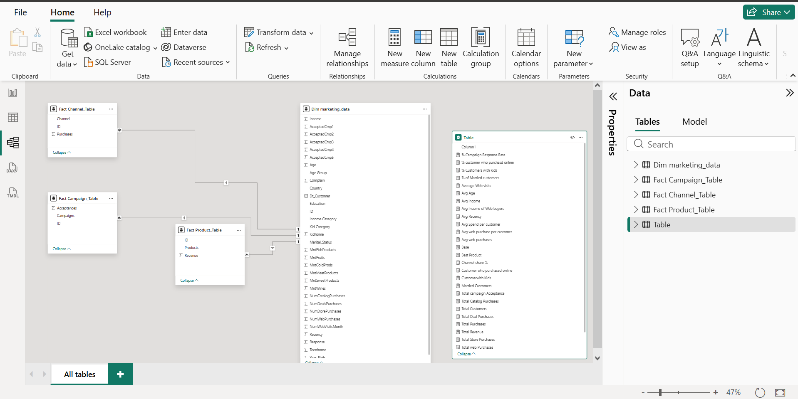
Figure 2.2: Power BI Data Model showing relationships between Customer, Campaign, Product, and Channel tables
2.3 Measure Creation (DAX)
Calculated measures were created using DAX to support key performance indicators used in the dashboard. These measures include total revenue, total purchases, response rate, average income, and web purchase metrics.
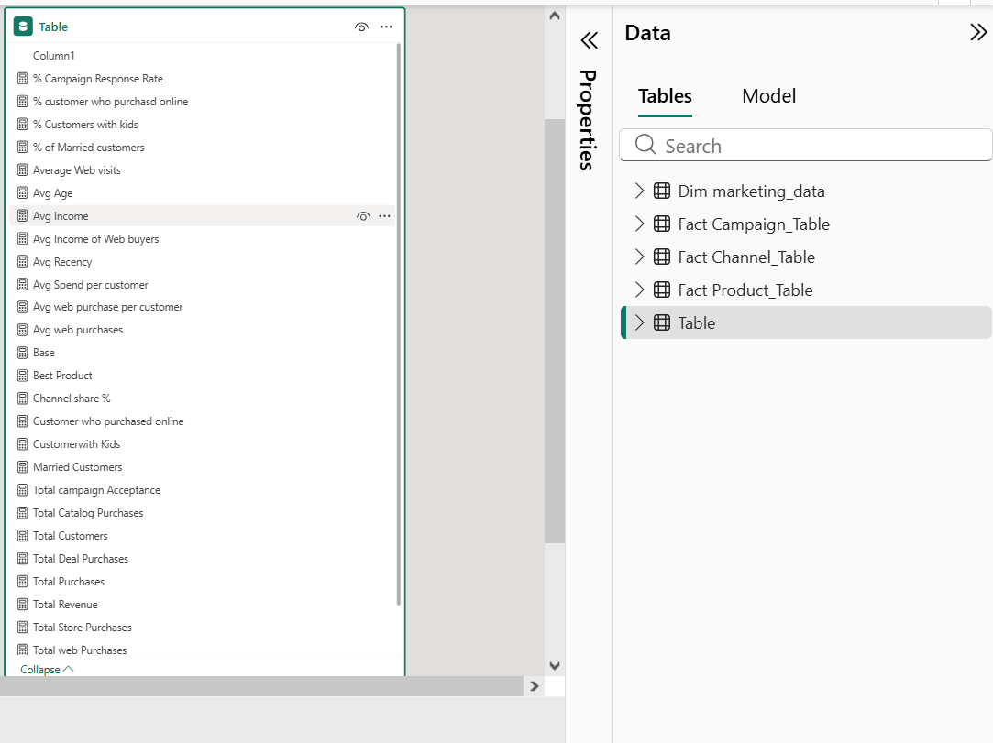
Figure 2.3: DAX Measures Panel showing calculated KPIs such as Total Revenue, Response Rate, and Web Purchase Metrics
2.4 Dashboard Design Structure
The dashboard was designed based on the business questions provided. Each page was structured to answer a specific analytical objective, ensuring clarity and logical flow across the report.
The structure includes:
- Customer Profiling
- Campaign Response & Engagement Analysis
- Commercial Performance (Products & Channels)
- Web Purchase Behavior Analysis

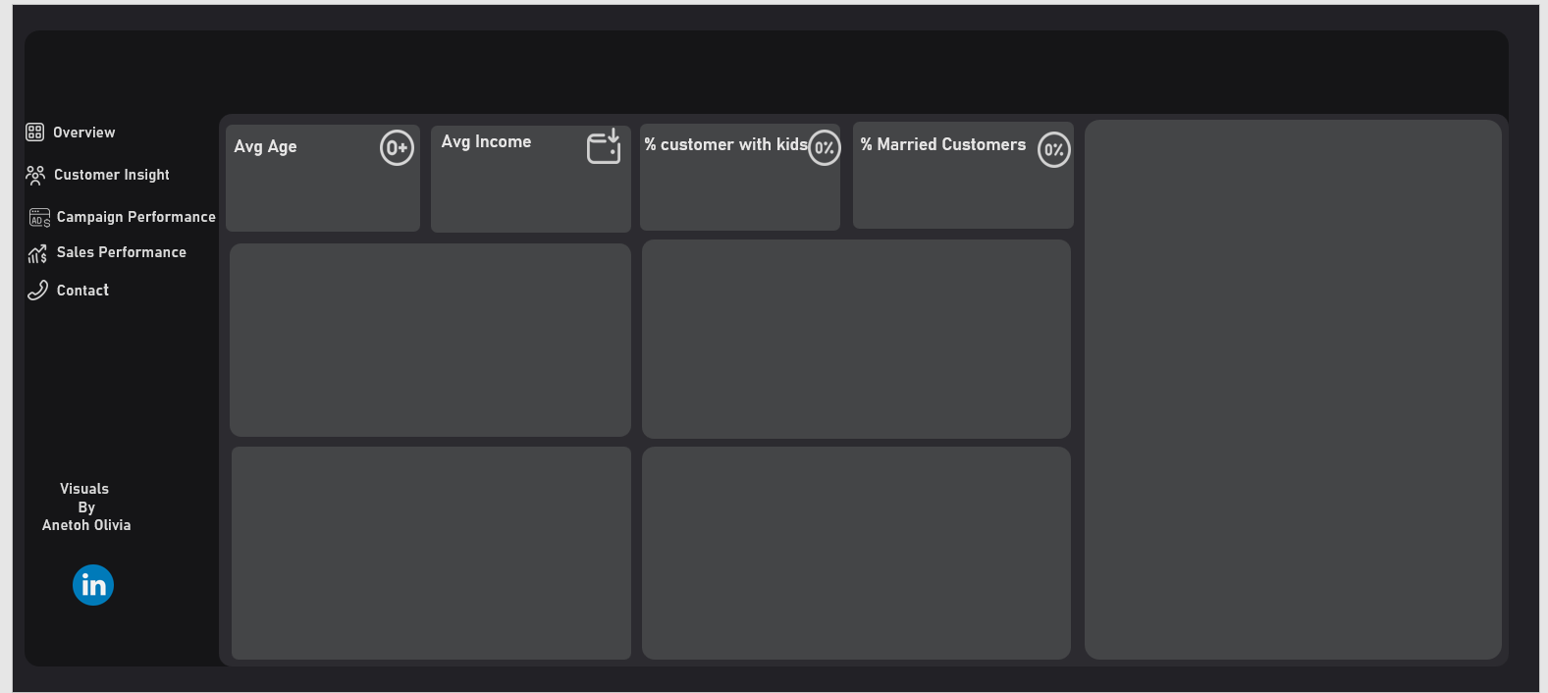 Figure 2.4: Dashboard Wireframe or Page Layout showing structure and flow of the Power BI report pages

3. Data Cleaning & Preparation
Business Question 1:
Are there any missing values or outliers in the dataset, and how were they handled?
Answer / Findings:
During the data exploration and cleaning process in Power Query, data quality issues were identified in the dataset.
Missing values were found in the Income column, while outliers were detected in both the Income and Age columns.
Specifically:
24 missing values were identified in the Income column
Extreme values were found in the Income column
Unrealistic age values were detected in the Age column
Data Cleaning Actions Taken:
To ensure data accuracy and reliability:
All identified outliers in the Income and Age columns were removed from the dataset
Missing values in the Income column were not deleted
Instead, missing Income values were replaced using the median income, to maintain data distribution and avoid bias
Data types were corrected to ensure proper analysis across all fields
Justification:
Outliers were removed because they could distort key business metrics such as average income, customer segmentation, and purchasing behavior.
Median imputation was used for missing income values because it is a robust method that prevents distortion caused by extreme values.
This approach ensured that the dataset remained accurate, consistent, and suitable for reliable analysis.
Conclusion:The dataset was successfully cleaned by removing outliers in the Income and Age columns and handling missing values in the Income column using median imputation. This ensured a clean and reliable dataset for accurate analysis in Power BI.

4. Customer Profiling Analysis
Business Question 2:
What does the average customer look like?
Answer / Findings:
The customer profiling analysis was conducted to understand the demographic structure and behavioral composition of the customer base.
The key findings are as follows:
The average customer age is 45 years, indicating a middle-aged customer base
The average income is $52,000, showing a mid-income customer segment
72% of customers have children, indicating a strong family-oriented customer base
39% of customers are married, with married customers forming the largest marital group
Customers with graduation-level education dominate the dataset
The majority of customers fall under the adult age group category
Spain is the leading country in terms of customer count.

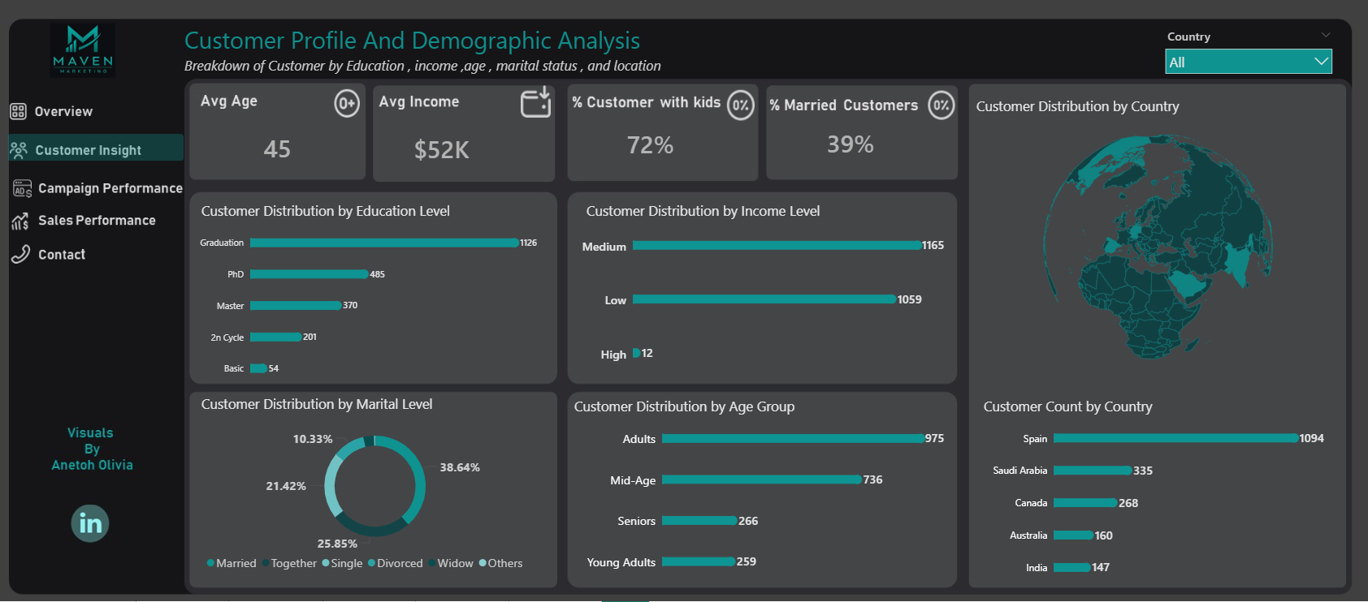
Figure 4.1: Customer Profiling Dashboard (Full Page View showing KPIs, demographics, and distribution charts)

Interpretation:
The customer base is largely composed of Adults, mid-income, educated individuals, with a strong presence of family-oriented customers. This suggests that the business primarily serves a stable, mature, and financially consistent customer segment.
Conclusion:
The average customer is a 45-year-old, mid-income, educated individual, most likely with children and a stable family structure. This profile provides a clear direction for targeted marketing and product positioning strategies

5. Campaign Response & Engagement Analysis
Business Question 3:
Which marketing campaign was the most successful?
Answer / Findings:
The campaign response and engagement analysis was conducted to evaluate how customers interacted with different marketing campaigns and how these campaigns influenced engagement levels.
The key findings are as follows:
The “Response” campaign recorded the highest performance, with the highest number of responses (337), making it the most successful campaign overall
Campaign 4 followed as the second-best performing campaign, with 167 responses
Campaigns 3 and 5 also performed moderately with similar response levels (163 and 162 respectively)
The overall response rate across all campaigns is 45%, indicating moderate customer engagement
Customers with children showed higher engagement levels (63%) compared to those without children
Customers with higher education levels (PhD and Graduates) showed stronger response behavior
Certain marital categories such as widowed and divorced customers showed relatively strong engagement compared to others
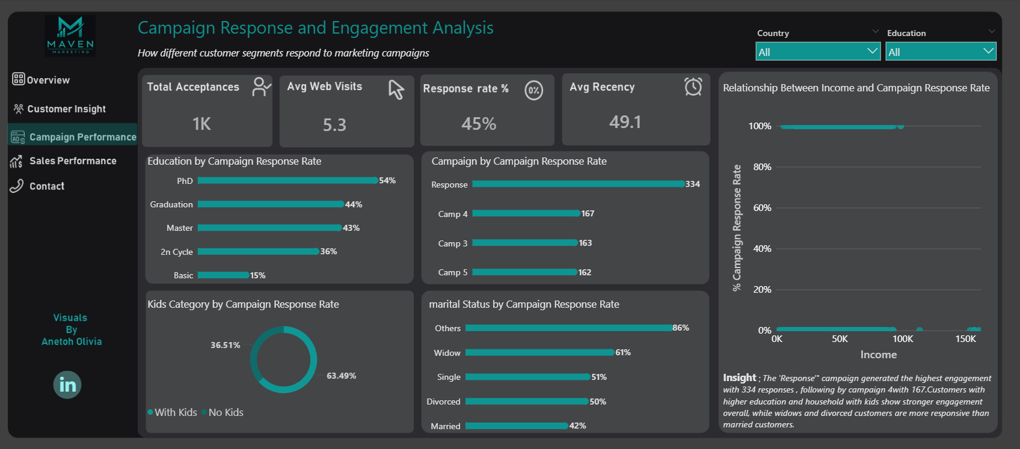

Figure 5.1: Campaign Response & Engagement Dashboard showing campaign performance, education response, and customer segmentation chart
Interpretation:
Campaign performance is strongly influenced by customer demographics. Customers with children and higher education levels tend to respond more positively to campaigns. However, campaign design also plays a major role, as the “Response” campaign significantly outperformed all others.
Conclusion:
The most successful campaign is the “Response” campaign, driven by strong engagement across key customer segments such as educated individuals and customers with children. Overall engagement is moderate, but clearly influenced by demographic characteristics and campaign structure.

6. Commercial Performance (Products & Channels)

Business Question 4:
Which products are performing best and which channels are underperforming?
Answer / Findings:
The commercial performance analysis was conducted to evaluate product revenue contribution and channel effectiveness in driving customer purchases.
The key findings are as follows:
The business generated a total revenue of $1M with 33K total purchases
Wine is the best-performing product, contributing the highest revenue at $680K
Meat is the second-best performing product, contributing $373K
Other products such as Gold, Fish, and Sweets contribute significantly less to overall revenue
In terms of channels, Store is the strongest purchase channel, followed by Web and Catalog
The Deals channel is the weakest performing channel, showing the lowest effectiveness in driving purchases
Channel distribution shows that purchases are spread across multiple channels, but Store and Web dominate overall performance
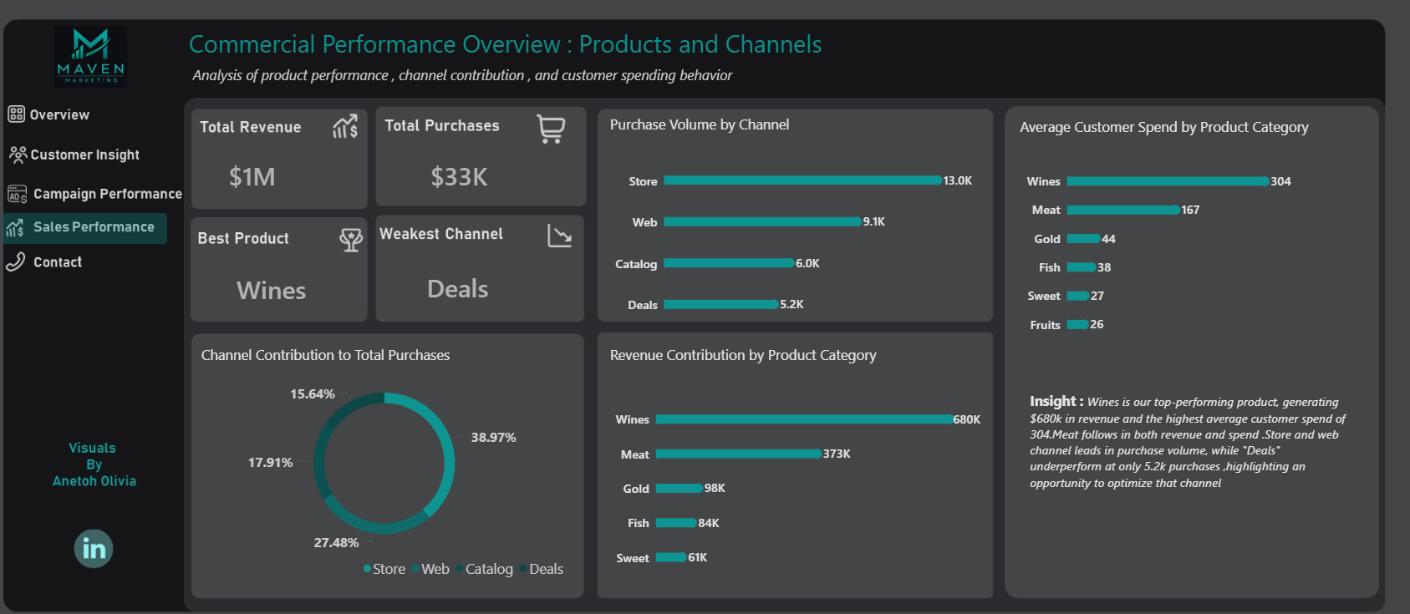
Figure 6.1: Commercial Performance Dashboard showing product revenue, channel contribution, and purchase distribution

Interpretation:
Product performance is heavily concentrated in premium categories, particularly Wine and Meat, which drive the majority of revenue. On the channel side, traditional and digital channels such as Store and Web perform strongly, while promotional channels like Deals underperform significantly.
Conclusion:
Wine and Meat are the leading revenue drivers for the business, while the Deals channel is the weakest contributor. This indicates that product strategy is more effective than promotional channel strategy, and improvements are needed in underperforming channels to balance overall

7. Web Purchase Behavior Analysis
Business Question 5:
What factors are significantly related to the number of web purchases?
Answer / Findings:
The web purchase behavior analysis was conducted to identify the key demographic and behavioral factors that influence online purchasing activity.
The key findings are as follows:
Customers without kids recorded higher average web purchases (4.4) compared to customers with kids (4.0), despite the fact that customers with kids showed higher engagement levels in earlier campaign analysis
Income level plays a significant role, with the medium-income group recording the highest web purchases (5.4), followed by high-income customers (4.7), while low-income customers recorded the lowest (2.6)
Age also influences behavior, with senior customers recording the highest web purchases (4.6), followed closely by mid-age customers (4.5)
Education level shows a clear upward trend, with PhD holders recording the highest web purchases (4.4), while basic education customers recorded the lowest (1.9)
The scatter plot analysis shows that most web purchase activity is concentrated within the $0–$100K income range, with medium-income customers showing the strongest engagement and conversion patterns
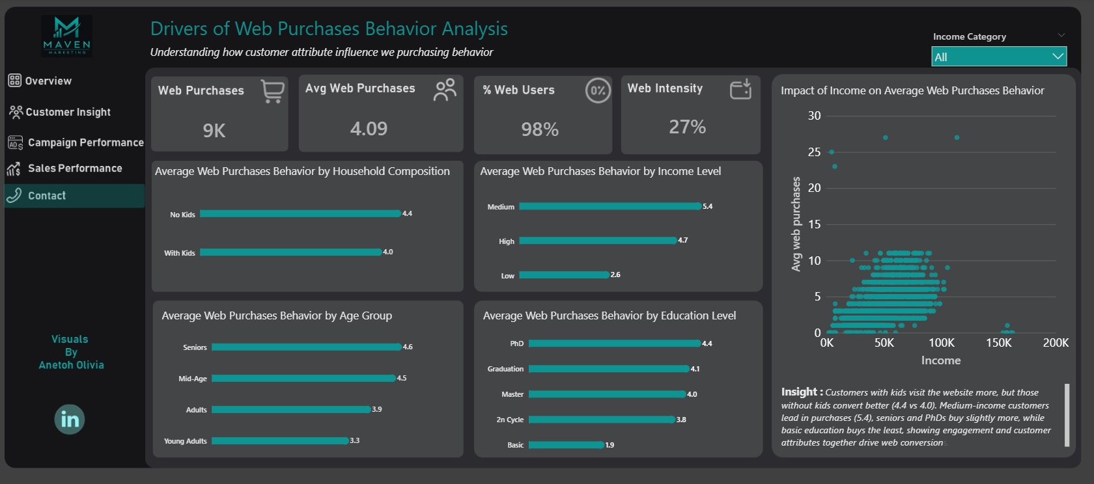
Figure 7.1: Web Purchase Behavior Dashboard showing household composition, income, age, education, and scatter plot analysis

Interpretation:
Web purchases are influenced more by demographic and socioeconomic factors than engagement alone. While customers with children show higher engagement in campaigns, customers without children tend to convert more in actual purchases. Income, education, and age are key drivers of online purchasing behavior.
Conclusion:
The strongest drivers of web purchases are income level, education level, and age. Engagement does not always translate to conversion, as customers with lower engagement in campaigns sometimes exhibit higher purchasing behavior online. This highlights the importance of targeting the right customer segments for conversion-focused strategies.

8. Recommendations

Based on the findings from the customer profiling, campaign analysis, product performance, channel performance, and web purchase behavior analysis, the following recommendations are proposed:
Focus marketing efforts on mid-income and educated customers, as they show stronger purchasing and conversion behavior
Improve the performance of the Deals channel, as it is the weakest performing channel in driving purchases
Strengthen targeting strategies for customers with children, especially in conversion campaigns, since they show high engagement but not always higher purchase conversion
Prioritize promotion and availability of Wine and Meat products, as they are the highest revenue-generating categories
Optimize the web purchasing experience to improve conversion consistency across all customer segments, especially for low-income and basic education groups

9. Conclusion

This analysis provided a comprehensive view of customer behavior, campaign effectiveness, product performance, channel contribution, and web purchase drivers using Power BI.
The results show that the business is primarily driven by mid-aged, educated, mid-income customers, with strong family representation. While marketing campaigns generate moderate engagement, actual purchasing behavior is more strongly influenced by income level, education, and age rather than engagement alone.
Product performance is heavily concentrated in Wine and Meat, while channel performance shows that Store and Web are the most effective channels. However, the Deals channel remains underperforming and requires strategic improvement.
Overall, the insights from this dashboard provide a strong foundation for improving targeting strategies, optimizing marketing efficiency, and increasing revenue generation through better customer segmentation and channel optimization.

